**Lab Report 07**

Problem

Given a file of fruit objects, create a program to populate a binary search tree with these fruits. Then, print the contents of the tree by using its traversal methods and remove a fruit from the tree.

Solution Description

I created the Fruit class according to the given specifications and implemented the Comparable type by properly programming the necessary methods, including compareTo. Then, I copied over the binary search tree program from the lecture example and created the front-end to populate and print the tree. Finally, I utilized the Fruit class’s Comparable methods to remove a fruit object from the tree chosen at random.

Problems Encountered

The tree would correctly print but the removal of the fruit did not work. After a bit of debugging, I realized that this was because the Fruit class’s compareTo method was incorrect. If the weight of the fruit is the same, it should compare both fruit’s types. If the types are the same, the method should return a positive number – in this case, one – to indicate to the tree’s search method that it was found.

4. A non-balancing tree adds nodes subsequently to the previous one while self-balancing trees add nodes according to their criteria, such as height or color, and utilizes rotations to ensure the tree is balanced.

5. O(lg(n))

6. O(n)

7.

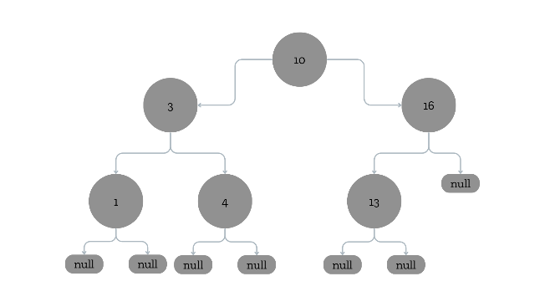

8.

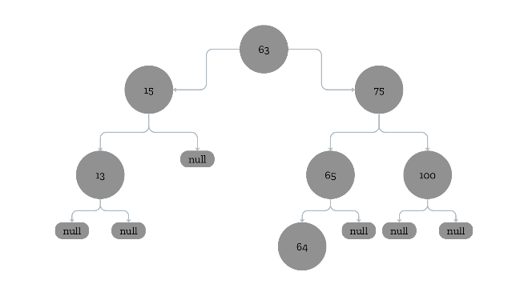

9.

Pre-order:

* 50
* 25
* 15
* 75
* 65
* 100

In-order:

* 15
* 25
* 50
* 65
* 75
* 100

Post-order:

* 15
* 25
* 65
* 100
* 75
* 50

10. The method would not work because many of the program has not been written correctly. For example, the call for the recursive method does not contain the necessary parameters to be called correctly, and the method is never called for the right subtrees, which means they would be ignored in the process. In order to rectify these issues, parameterize the recursive call of the method with the root node and call the recursive method within the return statement with the right child as well as the right one.